

LINT REPORT
Repository: https://github.com/jesrammar/Acme-Starters-B
May 08th, 2026
Content Table
Contenido
Introduction 2
Executive Summary 2
Revision Table 2
SonarLint Findings 2
Critical Security Vulnerabilities 3
Logic Errors & Dead Code 3
Unused Variables & Useless Assignments 3
Minor Code Smells & Optimizations 4
Conclusion 4

Introduction
This document presents the results of the static code analysis performed on the preliminary implementation of the system for Deliverable 2. The objective of this analysis is to ensure code quality, maintainability, and adherence to standard Java and Spring Boot coding conventions before the project scales further. The analysis was conducted using the SonarLint plugin integrated into the Eclipse IDE.

Executive Summary
The initial static analysis revealed a minor set of code smells and standard convention violations. No critical bugs or critical security vulnerabilities were detected in the current codebase. The majority of the reported issues are related to unused imports, naming conventions, and logging practices, which are typical during the early prototyping phases of development.

Revision Table
Revision number | Date | Description
1 | 08/05/2026 | The report was created and completed

SonarLint Findings
Here we present the results that we have found when we performed a SonarLint analysis on our project.

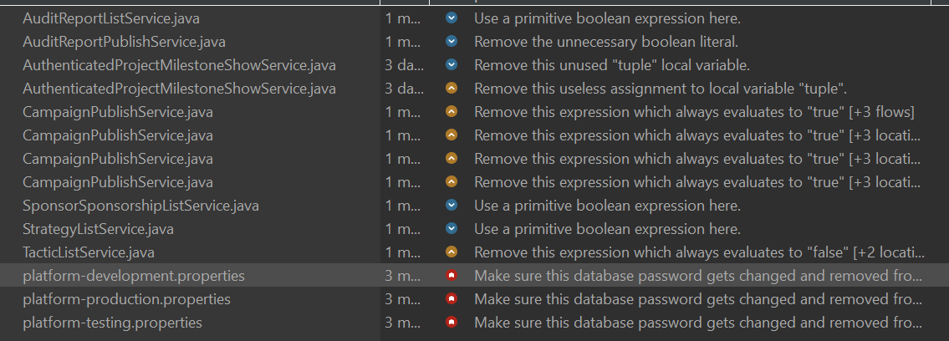

Critical Security Vulnerabilities
The Issue: Make sure this database password gets changed and removed from...
- Files Affected: platform-development.properties, platform-production.properties, platform-testing.properties
- What it is: You have hardcoded database passwords directly in your configuration files. This is a severe security risk, especially for the production environment, because anyone with access to the repository can see the credentials.
- How to resolve it: Remove the passwords from these files. Instead, use environment variables (e.g., ${DB_PASSWORD}) to inject the credentials at runtime, or use a secrets management tool.

Logic Errors & Dead Code
The Issue: Remove this expression which always evaluates to "true" / ...evaluates to "false"
- Files Affected: CampaignPublishService.java, TacticListService.java
- What it is: SonarLint detected conditional statements (like if statements or while loops) where the result is already predetermined. For example, checking if (x != null) when x was just instantiated, or something like if (true).
- How to resolve it: It usually indicates a flaw in your business logic or leftover code from debugging. If the check is truly unnecessary, remove the redundant if statement entirely to prevent confusion and dead code.
Unused Variables & Useless Assignments
The Issue: Remove this unused "tuple" local variable / Remove this useless assignment to local variable "tuple"
- Files Affected: AuthenticatedProjectMilestoneShowService.java
- What it is: You declared a variable named tuple and assigned a value to it, but you never actually read or used that variable anywhere else in the method.
- How to resolve it: It's just clutter. Delete the variable declaration and the assignment. It cleans up the code and slightly optimizes memory usage.
Minor Code Smells & Optimizations 
The Issue 1: Use a primitive boolean expression here.
- Files Affected: AuditReportListService.java, SponsorSponsorshipListService.java, StrategyListService.java
- What it is: You are likely using a wrapper class Boolean instead of the primitive type boolean in a place where it's not necessary (e.g., it will never be null). This causes unnecessary auto-boxing and unboxing in Java.
- How to resolve it: Change the Boolean object to a primitive boolean. It's a quick fix that slightly improves performance, but it won't break your app if you ignore it.
The Issue 2: Remove the unnecessary boolean literal.
- Files Affected: AuditReportPublishService.java
- What it is: You probably wrote something like if (isPublished == true) or return isValid == false;.
- How to resolve it: Simplify the expression. Change if (isPublished == true) to just if (isPublished). For false checks, use if (!isValid). It makes the code cleaner and easier to read.

Conclusion
Overall, the most critical takeaway from this report is the security vulnerability in our .properties files. We must address the exposed database passwords immediately to prevent potential security breaches, especially for the production environment.
Once the security issues are patched, we can treat the remaining warnings as general housekeeping. Cleaning up the redundant logic (evaluates to true/false), unused variables, and boolean literals will make our codebase cleaner, easier to read, and slightly more performant.

